I am the LORD your God.
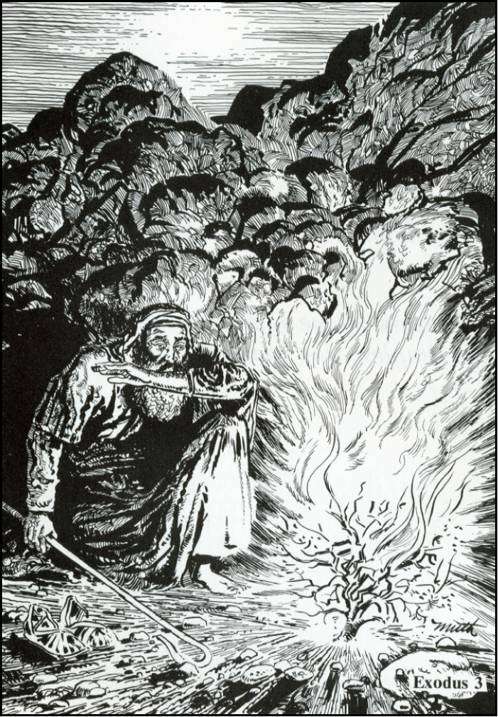
The 3 Purposes of the Law
1 Timothy 1:9-10

Romans 3:19-20

Psalm 119:1-5

Read Exodus 3
1. What is another name for Horeb?

2. What strange sight did Moses see?

3. Why didn't the bush burn up?

4. What did God tell Moses to do? Why?

5. Describe Moses' reaction as you look at the picture. Why do you think he feels that way?

6. In verse 14, God tells Moses his name. What is it?
יהוה
7. What do we learn about God from his name?

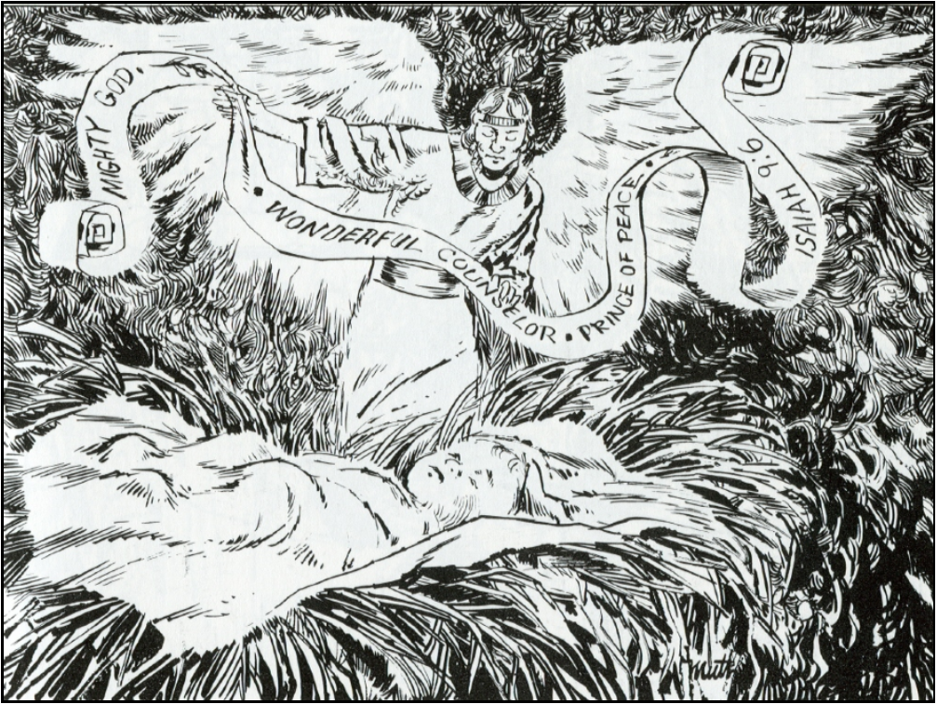
Read Isaiah 9:6
7. Who is the child in the picture?

8. Who is the other character?

9. What is he doing?

10. What is the child's name?

11. What did he come to do?

12. Why start our study of the 10 Commandments focusing on the LORD our God and his special names?

